Chain Flail Jetting Nozzle-Universal High-Pressure Water Jetting Nozzle

Product Overview
This premium universal chain flail nozzle is engineered for heavy-duty high-pressure water jetting machines. Designed to operate in harsh underground environments, it utilizes a robust rotary mechanism combined with heavy-duty skids to center the nozzle, delivering 360-degree cleaning and cutting power.
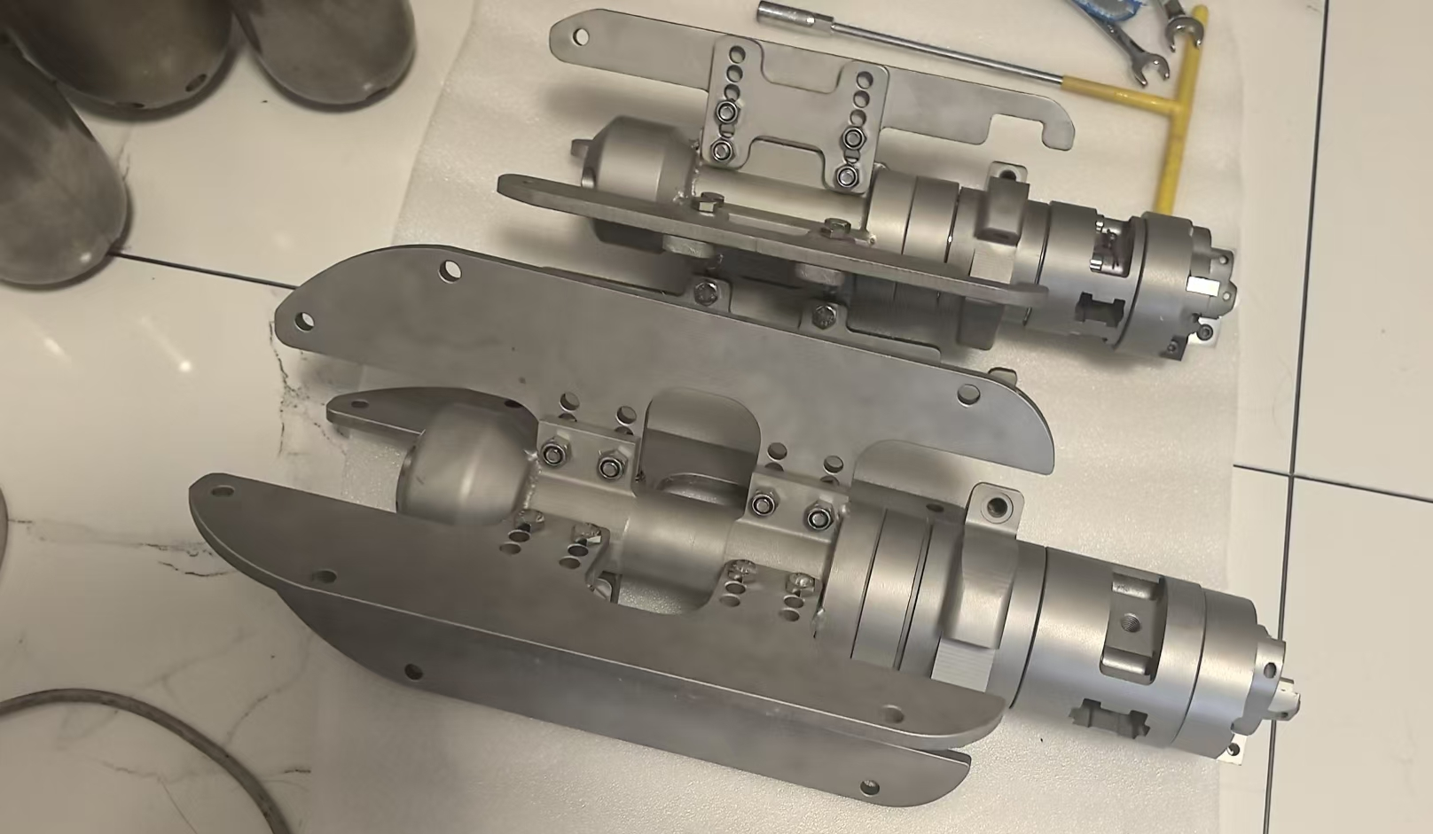
Material Construction: Manufactured from Special Stainless Steel, ensuring exceptional strength, extreme durability, and high resistance to wear and corrosion in highly abrasive pipe environments.
Core Functions:
- Removal of severe, hardened obstacles inside pipelines.
- Aggressive tree root cutting and clearing.
- Penetration and breaking down of solid foreign object intrusions.

Design based on visual reference: Heavy-duty rotary assembly with adjustable centering skids, solid body construction, and aggressive front-cutting profile.

Technical Parameters & Pricing
Model Variant | Applicable Pipe Size | Min. Flow Rate Req. | List Price
Standard Model | DN150 - DN300  (Approx. 6" to 12") | ≥ 85 L/min | USD $2,400.00
Heavy-Duty Model | DN300 - DN600  (Approx. 12" to 24") | ≥ 200 L/min | USD $3,200.00
* Note: Proper flow rate is strictly required to generate sufficient rotational torque for the chain flails and adequate pulling power.

Key Features & Advantages
- Adjustable Centering Skids: As shown in the product specifications, the heavy-duty stainless steel side runners ensure the rotating nozzle remains perfectly centered within the pipe diameter to prevent pipe wall damage and maximize cutting efficiency.
- Front Penetration Profile: Equipped with a robust front-end design to pierce through blockages before the main chain flails expand to scrape the pipe walls clean.
- High Productivity: Specifically optimized to handle complete blockages, significantly reducing the time required for municipal sewer and industrial pipeline restoration.

